Bug No 1

Issue: “No credit card required” should be aligned in the left along with the text box.

Priority: 1

Reason for Priority: This appears on the landing page and all other adjoining pages and is also the start of the main functionality of the product.

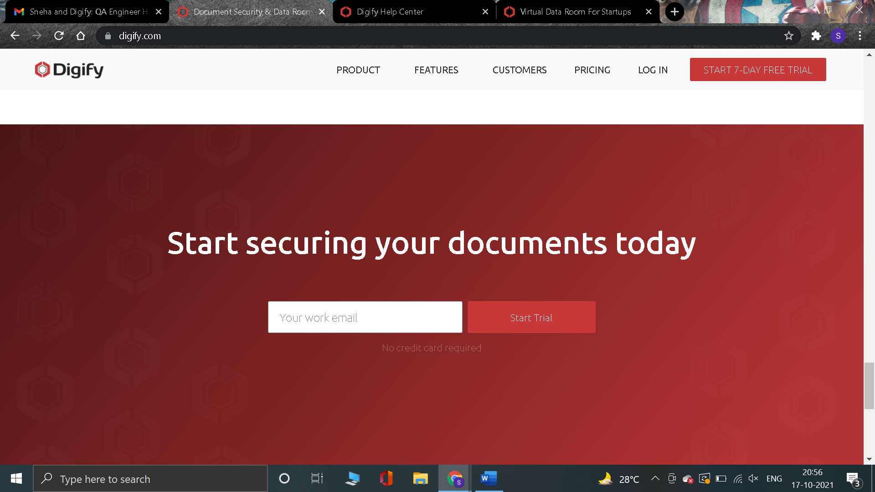

Expected alignment is as below.

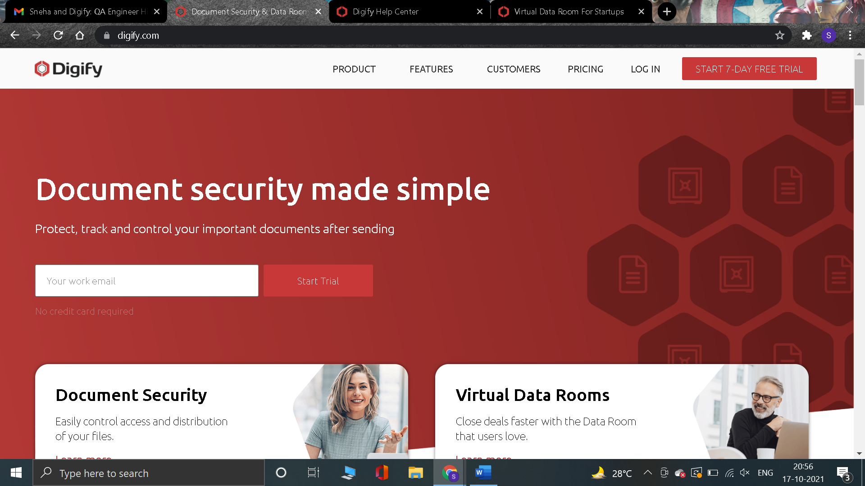

Bug No 2

Issue: The “less than” and “greater than” icons should be hyperlinks/hand-icons to indicate they are clickable. This is a normal cursor.

Priority: 1

Reason for priority: This confuses the user if the range of year can be changed on clicks the icons.

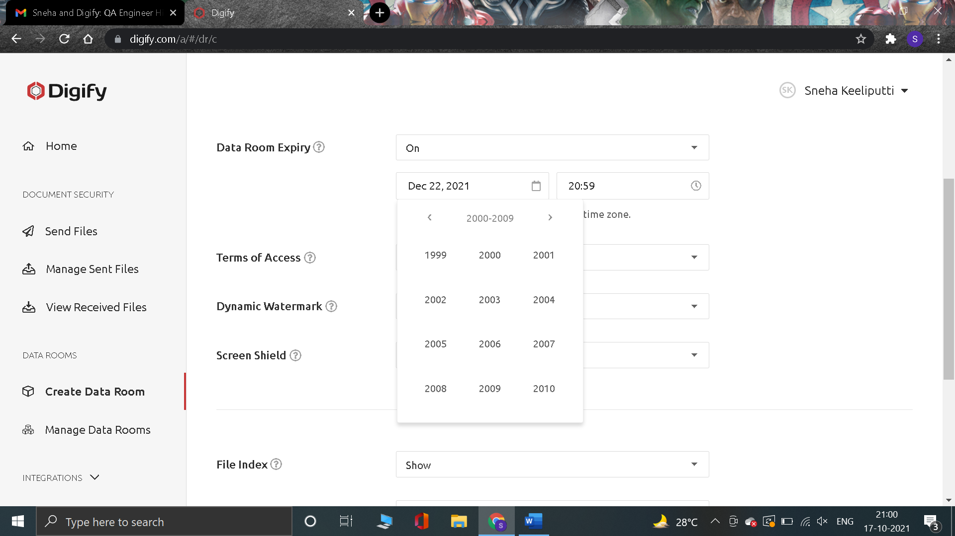

Bug No 3

Issue: On entering wrong pasword in Current Password textbox, the error thrown is incorrect.

Priority: 2

Reason for Priority: The functionality is correct but the error message is the issue, which serves the purpose.

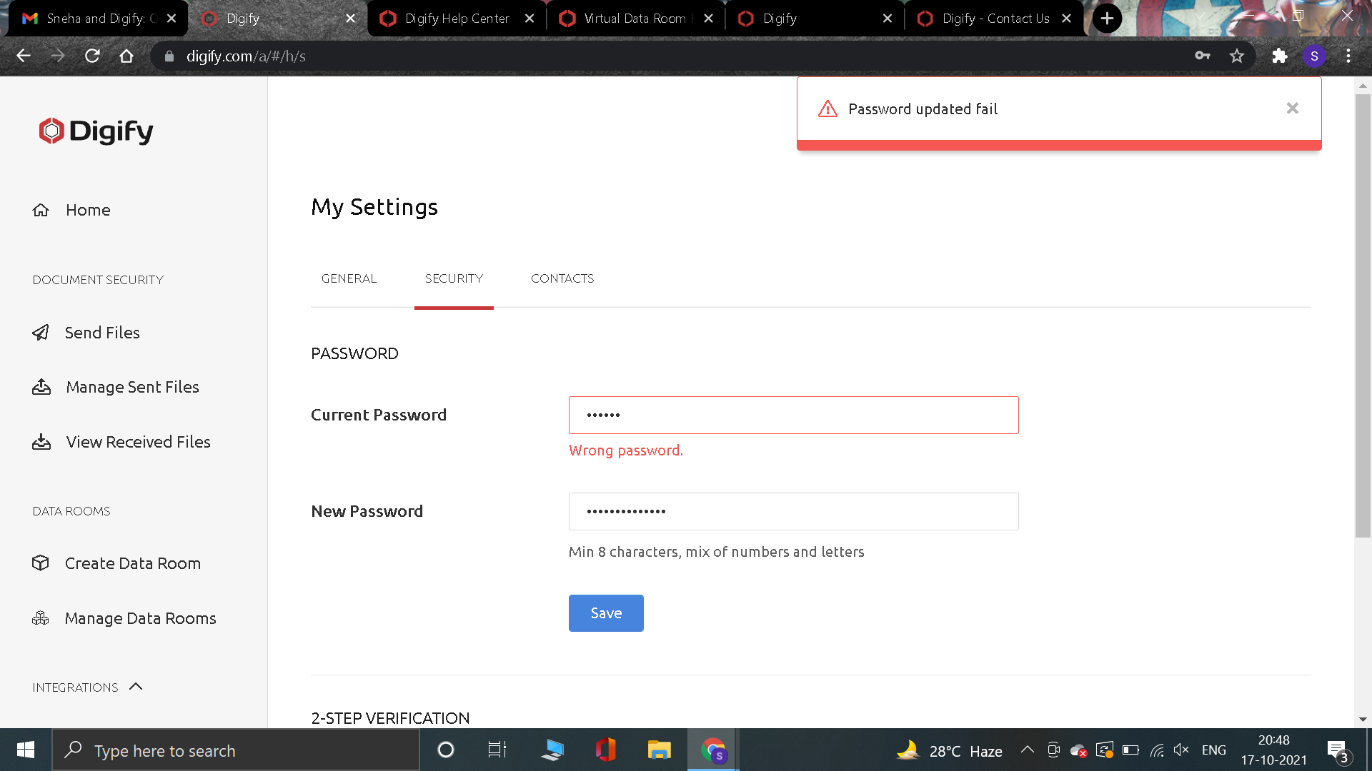

Bug No 4

Issue: The “Disable free account creation” button should be Grey to indicate it is to disable (as Blue button is to indicate Enable).

Priority: 2

Reason for priority: This is an color code issue, which will confuse the user on the purpose of the button as it is white button.

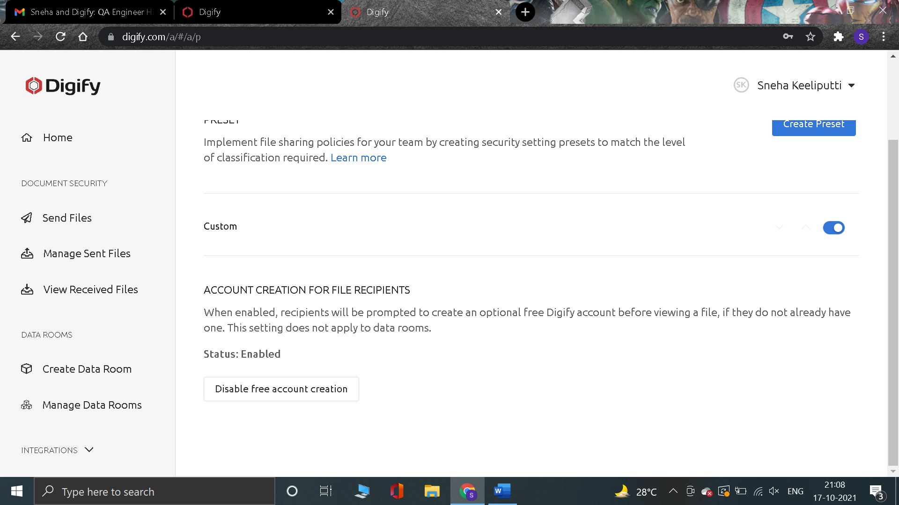

Bug No 5

Issue: The hand-icon on the “SK” or the photo area once uploaded, does not have any action, hence it should be a normal cursor.

Priority: 2

Reason for priority: This is an cursor indication issue, which does not distract the main functionality but confuses the user on the purpose of hand-icon if not clickable.

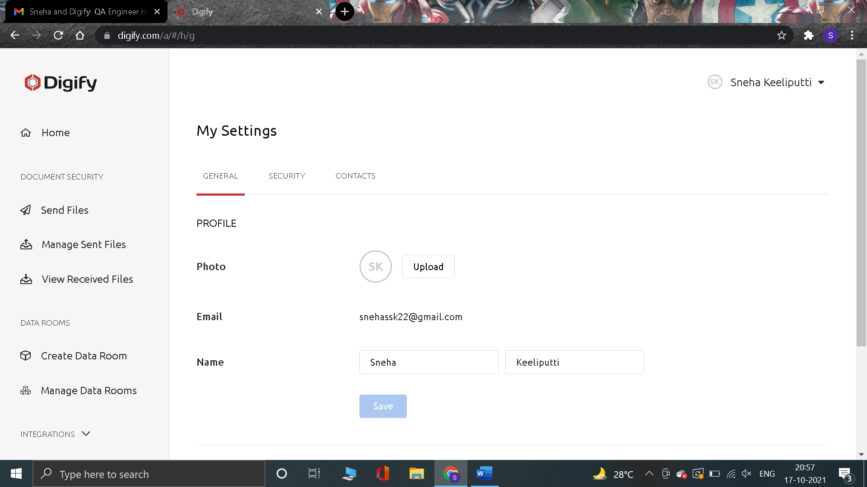

Bug No 6

Issue: The alignment of the “Document Expiry & Self-Destruct” link should be aligned along the “FEATURES” column items.

Priority: 2

Reason for priority: This is an alignment issue, which is on the landing page.

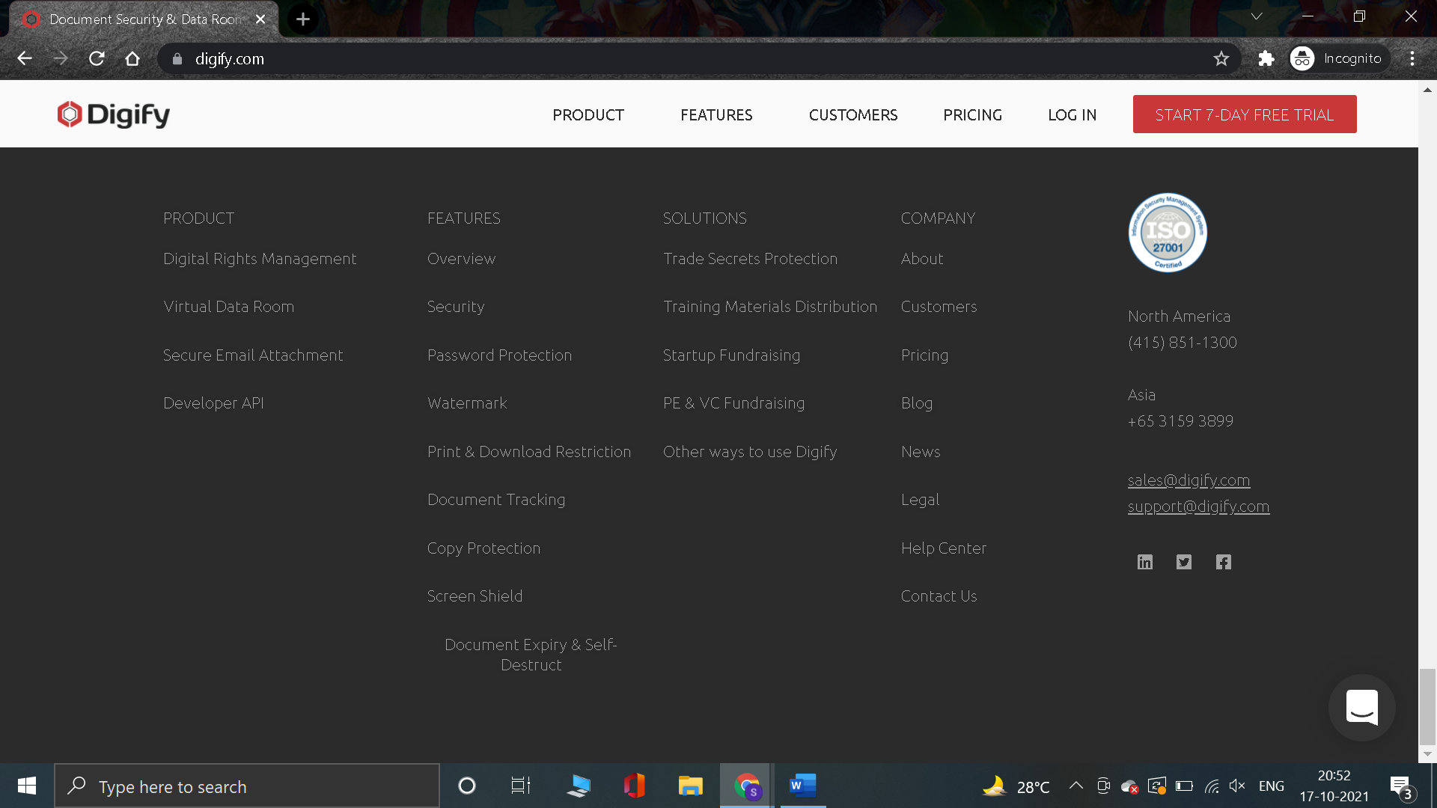

Bug No 7

Issue: The alignment of the “Next” button should be along the input field above to “Enter password” or the whole pop up size should be reduced to align better.

Priority: 3

Reason for priority: This is an alignment issue, which does not distract the main functionality.

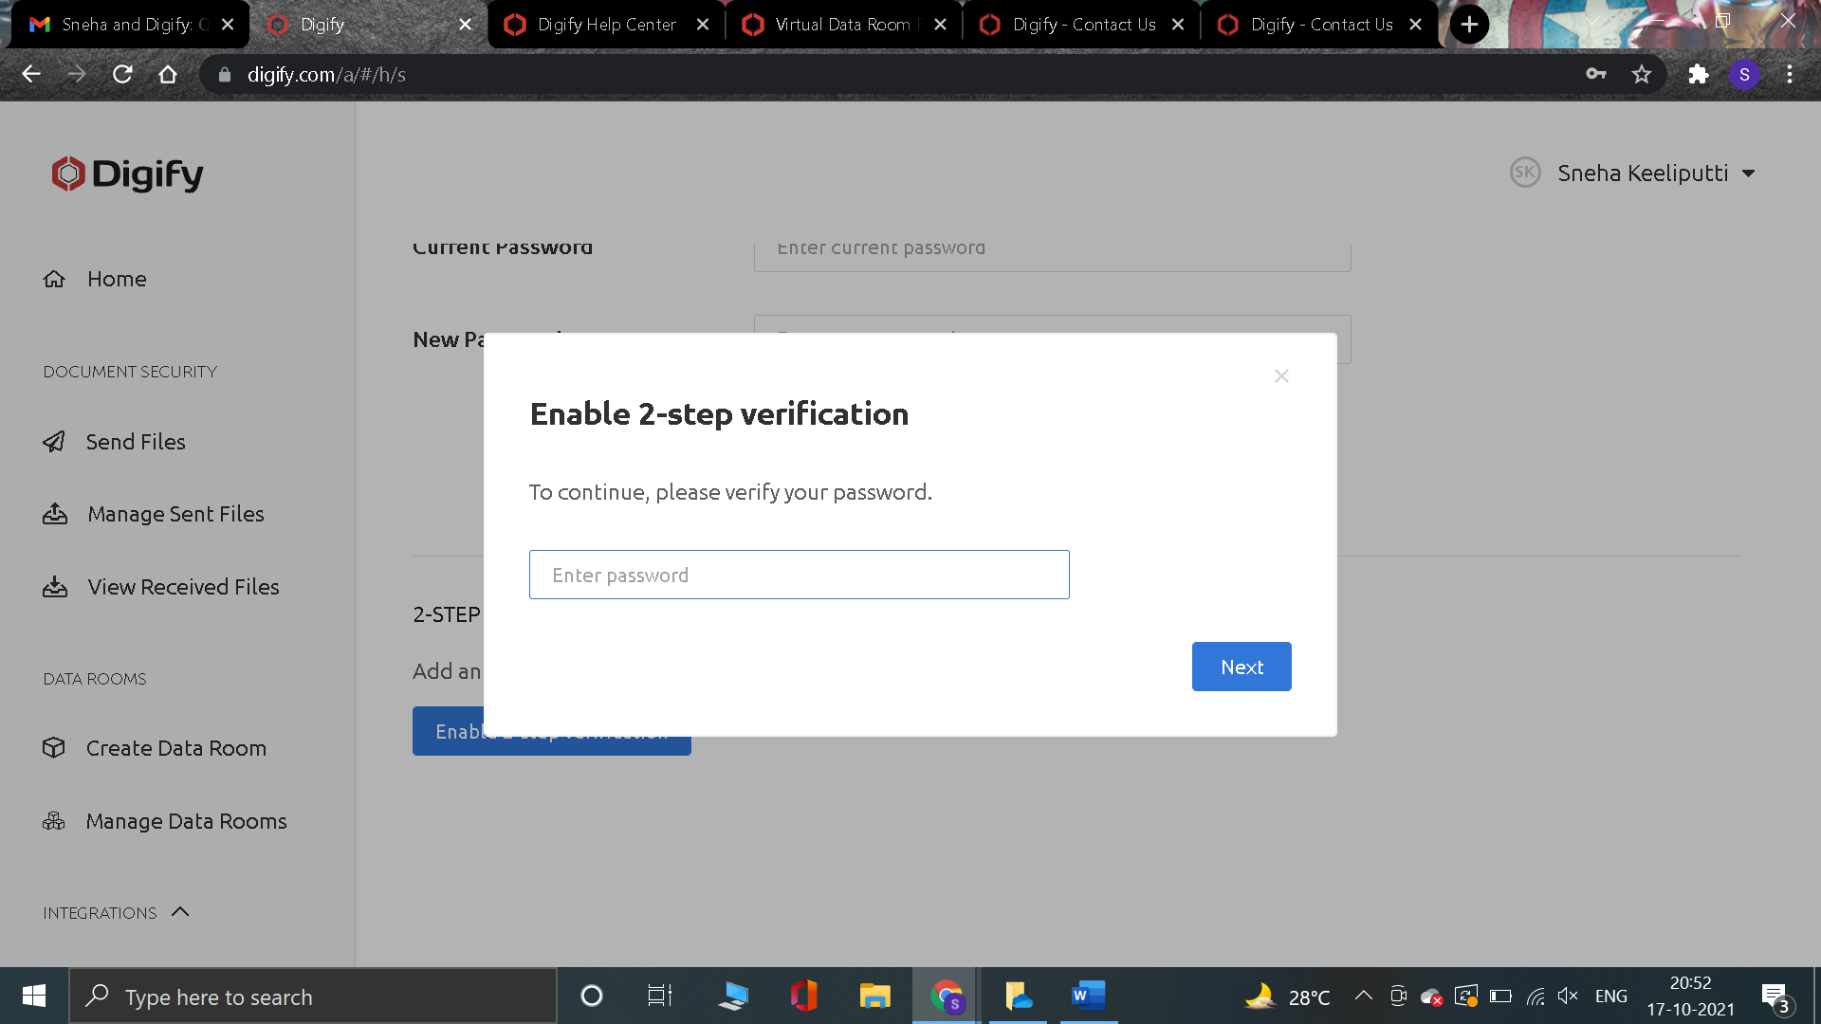

Bug No 8

Issue: The hand-icon on the pop-up after clicking on the document info “i” does not have any action, hence it should be a normal cursor.

Priority: 3

Reason for priority: This is an cursor indication issue, which does not distract the main functionality.

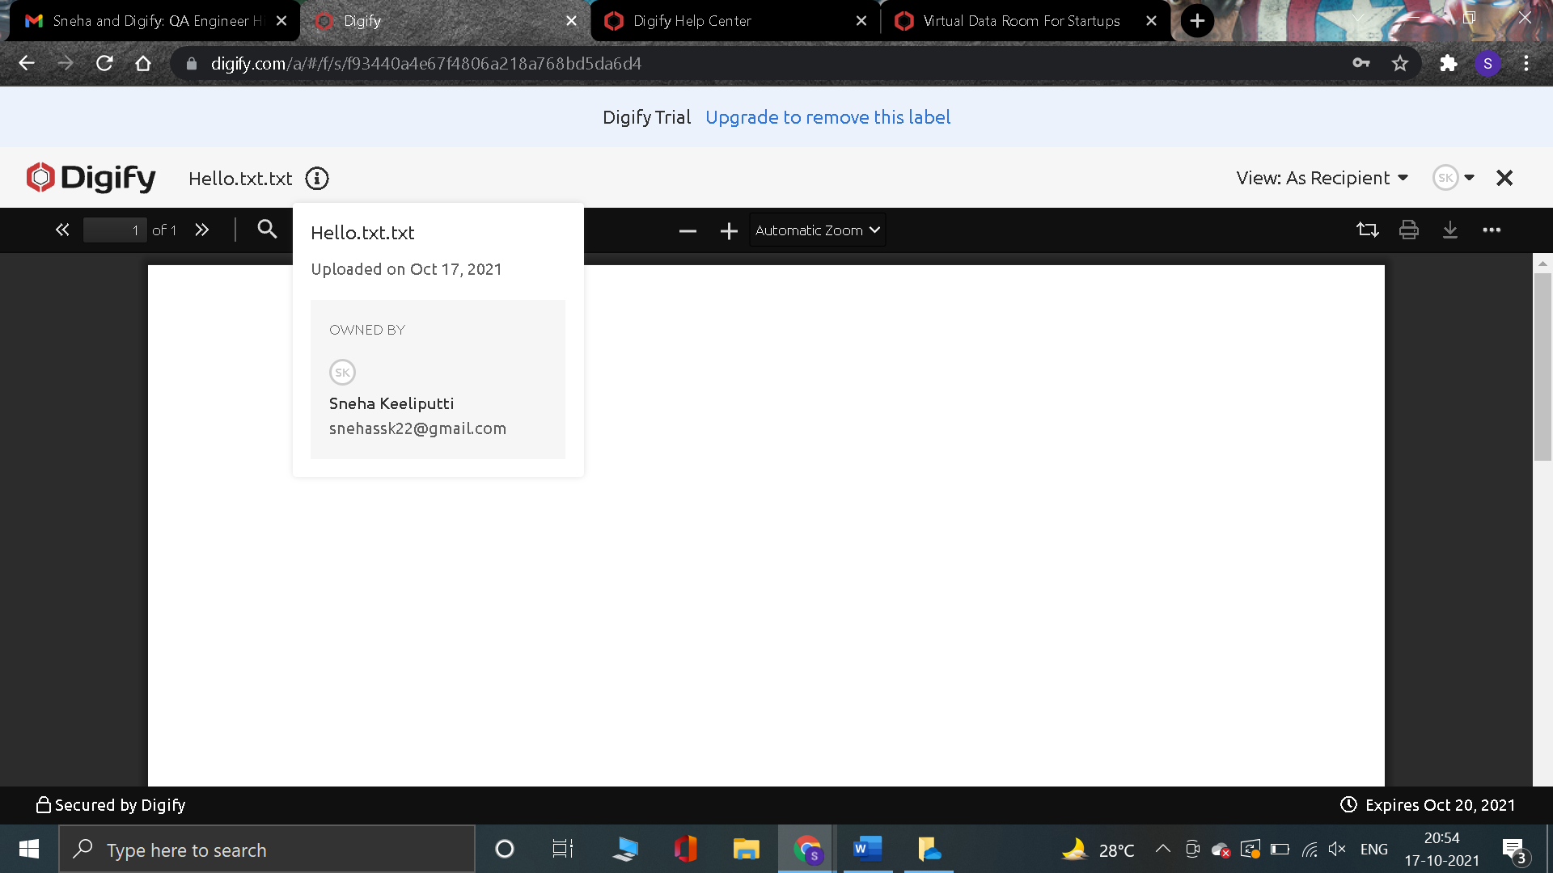

Bug No 9

Issue: The alignment of the content below “Track user activity with analytics” link should be aligned along the content rows of first two sections.

Priority: 3

Reason for priority: This is an alignment issue, which does not distract the main functionality.

